Change Responsibility tool

**Description:** The uses are able to find the responsibility that users have been assigned by user name, sure name, related office, email, role/responsibility and object type on a specific record or multiple record and change the responsibility by other user in order to switch the related user in order to be responsible of those records.

* **Account:** Account Admin, Account Manager, Lead Audit & Assurance Partner, Business Developer 1, Business Developer 2, Lead Rick Advisory Partner, Lead Financial Advisory Partner, Lead Consulting Partner, Account Owner, Lead Relationship Partner, Lead Tax & Legal Partner, Lead Client Service Partner.
* **Campaign:** Asset Developer, Campaign Owner from Business 1, Annual Plan Owner 2, Sub-Campaign Owner from Business 1, Sub-Campaign Owner from Business 2, Business Campaign Responsible, Business Development Plan Owner, Asset Second Owner, Business Sub-Campaign Owner, Campaign Owner, Business Development Plan Owner 2, Business Sub-Campaign Responsible, Sub-Campaign Marketing Owner, Campaign Marketing Owner, Business Campaign Owner, Asset Marketing Owner, Annual Plan Owner 1, Campaign Owner from Business 2.
* **Contact:** Contact Owner.
* **Business Relationship:** Relationship Admin, Relationship Partner, Relationship Owner.
* **Target Group:** Target Group Owner 1, Target Group Owner 2, Target Group Owner 3.
* **Team Member:** Engagement Partner, Engagement Manager, Engagement Admin, Sales Partner, Sales Manager, Opportunity Partner, Opportunity Manager, Opportunity Admin, Lead Partner, Lead Manager, Lead Admin, Pursuit, Relationship Supporter, Signatory of the left, Signatory of the right, Engagement Owner, Co-Manager, Co-Partner, LCSP, Account Owner, Account Manager, Account Admin, Business Developer, Lead Audit & Assurance Partner, Lead Tax & Legal Partner, Lead Financial Advisory Partner, Lead Risk Advisory Partner, Lead Consulting Partner, Lead Relationship Partner, Group Account Admin, Second Reviewer Partner (Tax), EQCR (RA), QA Partner (Consulting), Concurrent Reviewer (FA), Special Risk Reviewer (FA), Lead Member Firm, Member Firm.
* **Task:** Task Owner.

**User Stories: US-4732, US-5476, US-5589.**

**Trigger:** Update and remove the related user on the selected responsibility to be replaced by another user.

**Metadata:**

|  |  |
| --- | --- |
| Type | Name |
| Objects and Fields | **Account** (DEAL_AccountAdmin__c, DEAL_AccountManager__c, DEAL_LeadAuditAssurancePartner__c, DEAL_BusinessDeveloper2__c, DEAL_LeadRiskAdvisoryPartner__c, DEAL_LeadFinancialAdvisoryPartner__c, DEAL_LeadConsultingPartner__c, OwnerId, DEAL_LeadRelationshipPartner__c, DEAL_LeadTaxLegalPartner__c, DEAL_BusinessDeveloper1__c, DEAL_LeadClientServicePartner__c). **Campaign**(DEAL_mkt_AssetDeveloper__c, DEAL_mkt_CampaignOwnerFromBusiness1__c, DEAL_mkt_AnnualPlanOwner2__c, DEAL_mkt_SubCampaignOwnerBusiness2__c, DEAL_mkt_SubCampaignOwnerBusiness1__c, DEAL_mkt_BusisCampaignResponsible__c, DEAL_mkt_BDPOwner__c, DEAL_mkt_AssetSecondOwner__c, DEAL_mkt_BussSubCampaignOwner__c, DEAL_mkt_BDPOwner2__c, DEAL_mkt_BusinessSubCampaignResponsible__c, DEAL_mkt_SubCampaignMarketingOwner__c, DEAL_mkt_CampaignMarketingOwner__c, DEAL_mkt_BussCampaignOwner__c, DEAL_mkt_AssetMarketingOwner__c, DEAL_mkt_AnnualPlanOwner1__c, DEAL_mkt_CampaignOwnerFromBusiness2__c). **Contact** (OwnerId). **DEAL_BusinessRelationship__c** (DEAL_BusinessRelationshipAdmin__c, DEAL_BusinessRelationshipPartner__c, OwnerId). **DEAL_mkt_TargetGroup__c** (DEAL_mkt_TargetGroupOwner1__c, DEAL_mkt_TargetGroupOwner2__c, DEAL_mkt_TargetGroupOwner3__c). **DEAL_Team__c** (DEAL_TeamMemberUser__c). **Task** (OwnerId). |
| Apex Class | DEAL_ObjectResponsabilityController (All Methods) |
| Lightning component | DEAL_ObjectResponsability |
| Custom Metadata | DEAL_Responsability_Query |

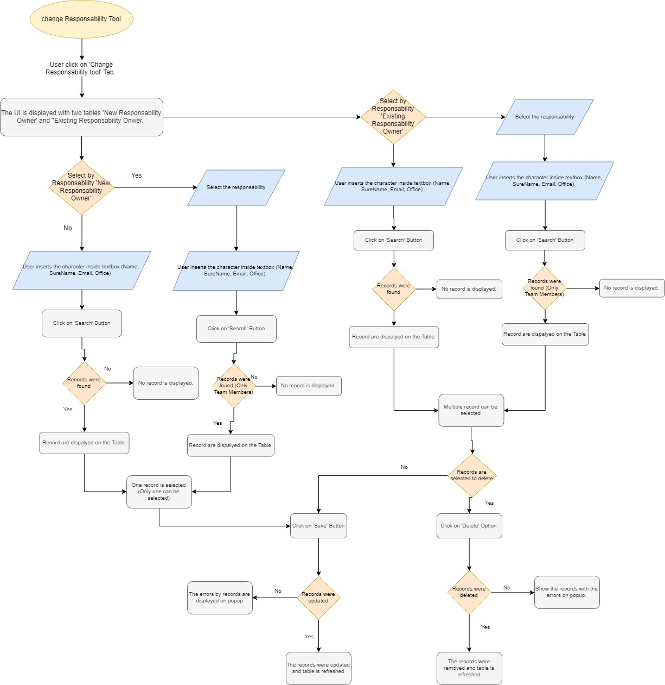

Business Developer tool

**Description:** Each global ultimate parent account on the org has a two users as business developer that they need to be assigned by tool by different responsibility according of the related responsibility to be assigned as business developer 1 or 2.

Related responsibility:

* Crown Jewel.
* Top Client.
* Deloitte Private.

**User story:** US-4839.

**Triggers:** Update the accounts business developer 1 and 2 that it was assigned by branch, region or singles account. 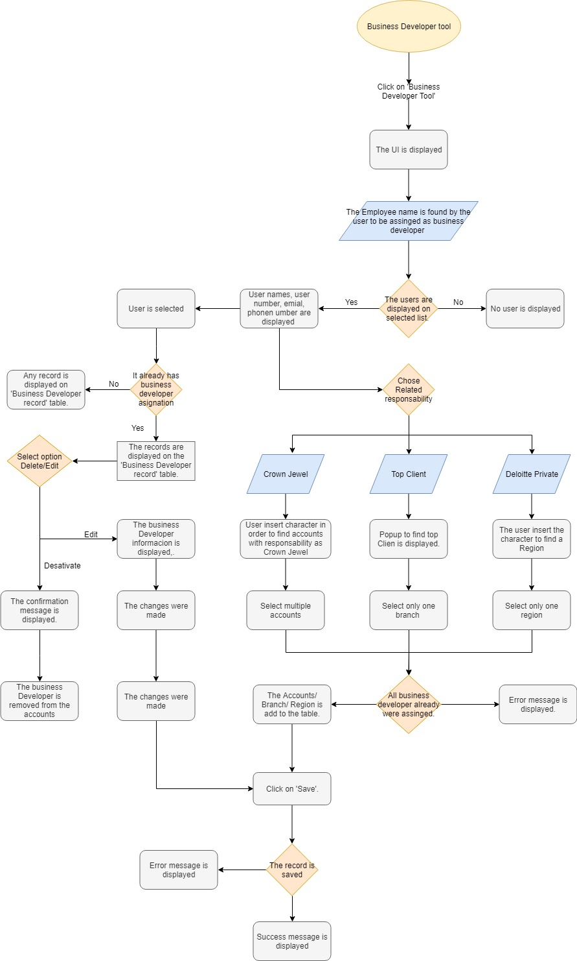

**Medadata:**

|  |  |
| --- | --- |
| Type | Name |
| Objects and Fields | **Account** (fields: DEAL_BusinessDeveloper1 __c, DEAL_BusinesDeveloper2__c). **DEAL_Branch__c** (Id). **DEAL_Region__c** (Id). |
| Lightning component | DEAL_BusinessDeveloperTool__c, DEAL_EmployeeNameEvent, DEAL_BusinessDeveloperRecords, DEAL_dynamicLookup. |
| Apex class | DEAL_BusinessDeveloperController, DEAL_DynamicLookup. |